## AR EDUCATIONAL APP FOR ELEMENTARY EDUCATION

**Submitted by**

**Kaushik Chaurasiya(23BCT10001)**

**Pushpender Singh(23BCT10011)**

**Vansh Manhas(23bct10008)**

**Supervisedby**

# Dr. Prashant Upadhyaya (E9437)

***In partial fulfilment for the award of the degree of***

# Bachelors of Engineering

**IN**

Computer Science with specialization in Blockchain Technology



**April,2024**

**TABLE OF CONTENTS**

**CHAPTER3. PRELIMINARY DESIGN**

1.Abstract........................................................................................................................3

2.Introduction...............................................................................................................3-4

3.Methodology.................................................................................................................4

4.Design........................................................................................................................5-7

5.Conclusion....................................................................................................................7

6.References.....................................................................................................................7

**CHAPTER 3**

**PRELIMINARY DESIGN**

1. **Abstract**

This report outlines the preliminary design and methodology for our AR (augmented reality) app for elementary education. And also, the UI (user interface) / UX (user experience) design of our app. The design focuses on simplicity, interactivity, and accessibility to engage young learners effectively. Key elements include visually appealing graphics, intuitive gestures, interactive content presentation, accessibility features, and feedback mechanisms. The AR app aims to enhance learning experiences through immersive and engaging educational activities while catering to diverse learning needs.

1. **Introduction**

Augmented Reality (AR) technology has the potential to revolutionize elementary education by providing immersive and interactive learning experiences. With the increasing availability of AR-enabled devices, there is a growing interest in leveraging this technology to enhance traditional teaching methods and engage young learners in innovative ways. This introduction provides an overview of the user interface (UI) design considerations for an AR app tailored specifically for elementary education.

The UI design of an AR app for elementary education plays a crucial role in shaping the learning experience for young students. Unlike traditional educational software, AR apps have the unique ability to overlay digital content onto the real world, creating an immersive learning environment that captivates students' attention and fosters deeper engagement.

In designing the UI for an AR app targeting elementary education, several key factors must be considered. Firstly, the interface must be intuitive and easy to navigate, catering to the digital literacy levels of young children. Visual design elements such as vibrant colours, age-appropriate graphics, and playful animations are essential for creating an inviting and stimulating learning environment.

Furthermore, the UI design should prioritize interactivity, allowing students to interact with virtual objects and explore educational content in a hands-on manner. Intuitive gestures such as tapping, swiping, and pinching should be incorporated to enable seamless interaction within the AR environment.

Accessibility is another critical consideration in UI design for elementary education AR apps. The interface should be designed to accommodate students with diverse learning needs, including those with disabilities. Features such as customizable settings, audio narration, and text-to-speech functionality can enhance accessibility and promote inclusive learning experiences.

Finally, the UI design should incorporate feedback mechanisms and assessment tools to monitor student progress and provide personalized learning experiences. Interactive quizzes, puzzles, and activities can be integrated to reinforce learning objectives and motivate student engagement.

1. **Methodology**

This section details the planned methodology for the making of UI/UX design of our AR app for elementary education

**User-Cantered Design:**

The app prioritizes user-friendliness for children through its design choices. The use of a tabbed interface at the top simplifies navigation, making it easy for young users to find the specific learning activities they're interested in. Categories like "Shapes" and "Body Parts" use clear and concise labels that are likely accompanied by corresponding icons for even easier recognition. This aligns with the understanding that young children often have better visual processing skills than reading comprehension.

**Mastery-based Learning:**

The "Progress" tab with its class breakdowns and progress bar suggests the app might incorporate elements of mastery-based learning. This approach allows children to progress at their own pace, mastering smaller chunks of content before moving on to new topics. The progress bar provides a visual representation of their accomplishment, potentially motivating them to continue learning.

**Gamification Elements:**

The app may incorporate subtle gamification elements to make learning more engaging. The progress bar itself can be seen as a game mechanic, offering a sense of achievement as the child fills it up. Depending on the app's functionalities, there could be points awarded for completing tasks or badges earned for mastering certain topics. These elements can add a layer of fun and encourage children to return to the app for extended learning sessions.

**Scaffolding and Differentiation:**

The possible presence of different "Class" levels (e.g., Class 1, Class 4) suggests the app might offer scaffolded learning experiences. This means the difficulty and complexity of the content can be adjusted based on the child's age or skill level. This caters to individual learning styles and paces, ensuring that children are neither overwhelmed nor underchallenged.

**Emphasis on Visuals and Interaction:**

The app likely emphasizes visual learning, which is often strong in young children. Interactive elements within the app's various sections can further enhance engagement and knowledge retention.

**4.Design**

This shows how our UI/UX design works. To design all of this we have used Figma and drawn all of this by ourselves

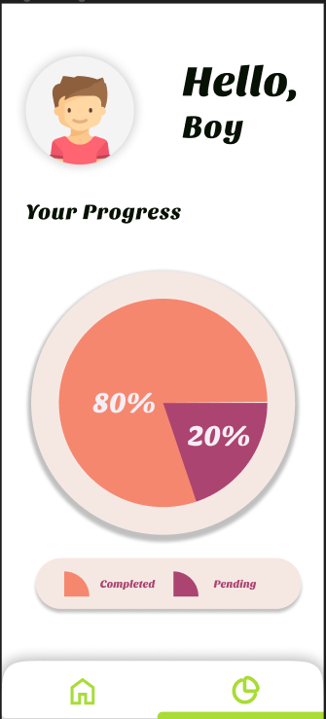

Welcome! Upon opening the app, you're greeted by name and presented with a snapshot of your progress. Visualized through vibrant progress bars: a pink "Completed" bar shows a remarkable 80% progress, while a purple "Pending" bar indicates just 20% left to conquer.

Feeling a surge of inspiration? The "Start" button stands out, eager to catapult you back into the heart of your learning odyssey. It's not just a button; it's your gateway to mastering the final 20% and embracing the satisfaction of completion. Let's hit "Start" and transform your ambition into achievement.

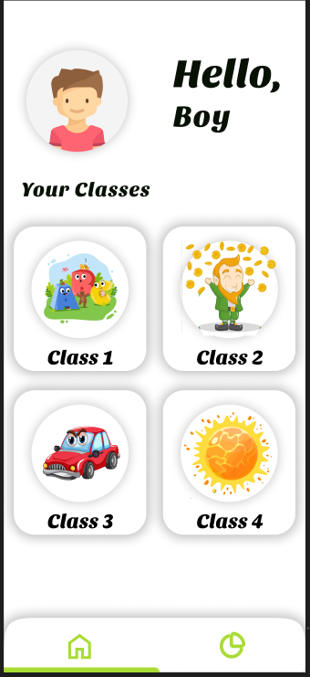

.

Navigate to the Home tab to discover the "Your Classes" section, showcasing four vibrant classes: Class 1, Class 2, Class 3, and Class 4. Here, you can effortlessly select the class that matches your child's current level. Tailored for the imaginative minds of elementary students, our platform comes alive with a playful, cartoonish theme. This captivating design not only draws them in but also transforms learning into an adventure they'll love

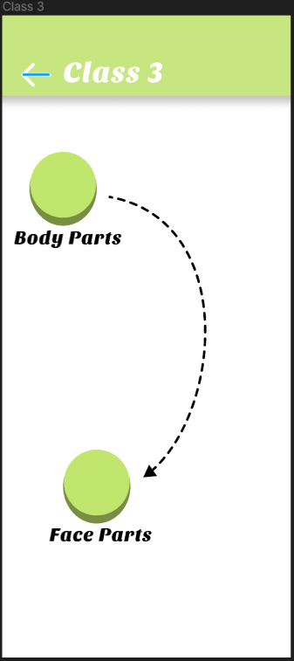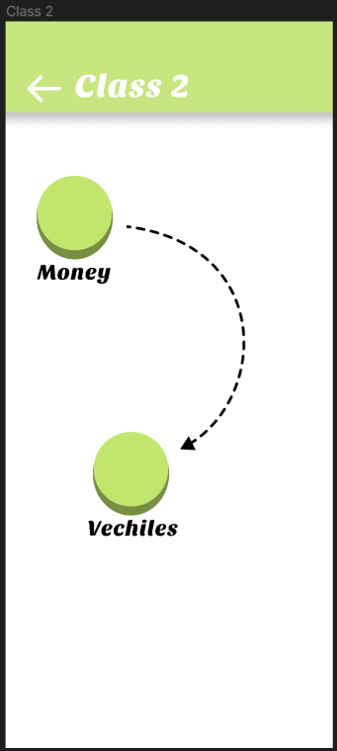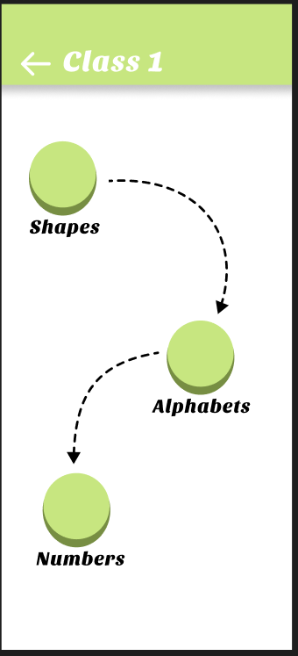

Once you've chosen your child's class, a world of tailored chapters unfolds, thoughtfully curated for your little learner. For Class 1, we delve into the colourful realms of Shapes, Alphabets, and Numbers. We understand the spirited nature of young minds, always on the move, rarely sitting still with a book. That's where our app shines! Available on your mobile, it brings learning to life through interactive activities and vivid, real-world images. It's not just about studying; it's about embarking on a joyful journey of discovery. Let your child explore.

Welcome to Class 2, where the excitement continues with chapters dedicated to Money and Vehicles. Here, learning leaps off the pages as we bring currencies and vehicles to life in ways you've never imagined. No more static images or abstract concepts; with our app, students can interact with currencies, exploring their intricate details, and dive into vehicles, rotating them to see every angle and aspect in stunning, lifelike detail. It's not just about learning; it's about experiencing the world in a whole new dimension. Come, let's embark on this extraordinary journey together!

Welcome to Class 3, where we dive into the fascinating realm of body exploration! Here, we've broken down the intricate study of body parts into two captivating chapters: Body Parts and Face Parts.

In the Body Parts chapter, students will encounter every aspect of the human anatomy, excluding the face. But fear not! The Face Parts chapter ensures that every feature of the face gets its spotlight.

But here's where the magic truly unfolds. Picture this: an interactive mobile screen where body parts float, inviting curious minds to explore. Rotate them, place them on your desk, or anywhere else your imagination takes you. With our app, the possibilities are endless. It's not just learning; it's a journey of discovery and wonder. Let's dive in and uncover the mysteries of the human body together!

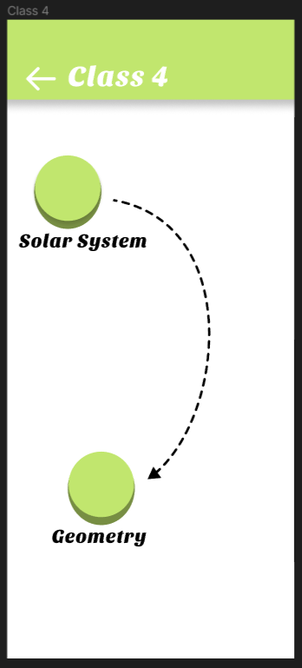Welcome to the grand finale of our AR educational adventure for elementary students! Get ready to embark on an exhilarating journey through the cosmos and the enchanting world of geometry.

In the Solar System chapter, prepare to be mesmerized as you explore the vastness of space like never before. With our app, the wonders of our planets come to life in stunning detail, allowing young minds to witness the magnificence of the universe firsthand. From the fiery depths of the sun to the icy rings of Saturn, every celestial body is at your fingertips, offering an immersive experience that sparks curiosity and fuels exploration.

But the excitement doesn't end there! Dive into the Geometry chapter and unlock the mysteries of shapes and dimensions. Say goodbye to flat, two-dimensional textbooks and hello to a world of depth and perspective. With our app, students can delve into the realm of 3D geometry, manipulating shapes and visualizing concepts with ease. From pyramids to prisms, every angle and facet is illuminated, empowering learners to grasp complex ideas with clarity and confidence.

1. **Conclusion –**

The preliminary design and methodology showcased in this paper offer a tantalizing glimpse into the future of education through our AR app. Here, innovation meets imagination as we unveil a comprehensive approach to learning that is as captivating as it is effective.

Step into a world where education comes to life in vivid detail. Our AR app isn't just a tool—it's an immersive experience that transports learners to new dimensions of knowledge and understanding. Picture yourself exploring the wonders of history, science, and mathematics in ways you never thought possible

But what sets our app apart isn't just its stunning visuals or interactive features; it's the meticulous methodology behind its creation. Every pixel, every line of code, has been crafted with care and precision to ensure a seamless user experience. From user interface design to content development, our team has spared no effort in creating an app that is both intuitive and engaging.

So, join us on this journey into the future of education. Let's redefine learning together and inspire generations to come. Welcome to the revolution.

1. **References : https://www.freepik.com/**